REPORT FOR: | GOVERNANCE AUDIT AND RISK MANAGEMENT COMMITTEE
Date of Meeting: | 29 March 2012
Subject: | INFORMATION REPORT  Insurance Risks
Responsible Officer: | Tom Whiting, Assistant Chief Executive
Exempt: | No, except for Appendix 2, which is exempt on the grounds that it contains “exempt information” under paragraph 3 of Part I of Schedule 12A to the Local Government Act 1972 (as amended) in that it contains information relating to the financial or business affairs of any particular person (including the authority holding that information).
Enclosures: | Appendix 1 – Claims Analysis  Appendix 2 – Actuarial Report (Exempt)

Section 1 – Summary

This report provides information on the Council’s current insurance arrangements, including self-funding and fund performance, and outlines the main insurable risk exposures faced by the Council.

FOR INFORMATION

Section 2 – Report

The Insurance Service

2.1 The Insurance Service comprises a team of three officers, who strive to deliver an efficient, economic and high quality service that meets customer needs, corporate priorities and statutory requirements.

2.2 The main aims and areas of responsibility of the service are:

- To provide a commercial insurance service, including the maintenance and development of an extensive insurance programme

- To provide a comprehensive claims handling service to internal and external customers

- To provide advice and guidance to the Council on all insurance matters

- To work in partnership with all departments to manage and reduce the Council’s exposure to insurable risk

2.3 The service arranges insurance for property valued in excess of £1bn; over 300 commercial vehicles; and significant liability exposures.

2.4 Over 600 claims are received each year and annual claims expenditure exceeds £1m.

Policy Cover

Property Insurance

2.5 The Council’s Property insurance policy is underwritten by Zurich Municipal and is subject to a two-year long-term agreement, which expires on 31 March 2014.

2.6 There are three classifications of property under the policy, namely general properties, housing properties, and education properties.

2.7 General properties are insured to the sum of £164m; housing properties to £566m; and education properties to £349m.

2.8 Academies are not insured under the Council’s central insurance arrangements, as they cannot benefit from the Council’s self-insurance provision under UK insurance law.

2.9 Under the terms of the policy a £200,000 policy excess applies to each and every claim.

2.10 Subject to the policy excess, cover is provided for Fire; Explosion; Aircraft; Malicious Damage (including Riot & Civil Commotion); Earthquake; Storm or Flood; Escape of Water; Impact; Escape of Water from Automatic Sprinkler Installations; Subsidence; Theft; Accidental Damage; and Damage to Fixed Glass.

2.11 Insurance is also arranged for Business Interruption, covering increased cost of working, loss of gross revenue, or loss of rent receivable resulting from damage to premises arising from the perils specified in paragraph 2.10.
2.12 For general and housing properties, claims for Fire; Lightning; Explosion; and Aircraft below the policy excess are met from the Council’s internal insurance provision, subject to a £50 excess.

2.13 All claims below the policy excess for education properties arising from any of the perils specified in paragraph 2.10 are met from the Council’s internal insurance provision. A £250 excess is charged to schools in respect of each loss.

2.14 The policy is subject to an annual aggregate of £1,000,000. All claims within a policy year, irrespective of whether they are below the policy excess, count towards the annual aggregate and once this has been exceeded any further claims within the policy year will be met by insurers. This is therefore the maximum financial liability attaching to the Council for all property claims in any one policy year, thus providing financial stability to the Council.

2.15 Separate insurance is held in respect of Terrorism, which is currently arranged with Aon Ltd. All of the Council’s general, housing and education properties are declared to the insurers and the limit of indemnity in respect of all claims in any one policy year is £35m.

Liability

2.16 The Council’s Liability insurance policy is underwritten by Zurich Municipal and is subject to a two-year long-term agreement, which expires on 31 March 2014.

2.17 The policy covers Public Liability; Employers’ Liability; Professional Errors & Omissions; Libel & Slander; and Land Charges.

2.18 Public Liability insurance covers claims for compensation made against the Council by third parties for accidental bodily injury, illness or death, and accidental loss of, or damage caused to, property. Payment of compensation under the policy is not automatic; it depends on a claimant showing that the Council has been negligent.
2.19 Employers’ Liability insurance covers claims for compensation for injury or disease suffered by anyone under a contract of service or apprenticeship with the Council arising out of and in the course of their employment. It also covers costs and expenses incurred in the defence of any prosecution brought or made against the Council in respect of a breach of the Health and Safety at Work etc Act 1974 or any prosecution under the Corporate Manslaughter and Corporate Homicide Act 2007. Again, payment of compensation under the policy is not automatic; it depends on a claimant showing that the Council has been negligent.
2.20 Professional Errors & Omissions insurance covers the Council for all sums it may become legally liable to pay to a third party for financial loss arising as a result of a wrongful act committed or alleged to have been committed by a councillor or employee in or about or as a consequence of their statutory duties arising out of the business. It also provides automatic cover for services carrying out works of a professional nature, such as providing advice, design or specification, outside of their statutory duty or powers, except for Architectural; Design and Build; and Treasury Management, which are subject to a requirement to declare these services individually.
2.21 The Public and Employers’ Liability and Professional Errors & Omissions insurance is subject to a £50m limit of indemnity and a £300,000 policy excess, however claims below the excess are met from the Council’s internal insurance provision.

2.22 Libel & Slander insurance provides cover for all sums that the Council becomes legally liable to pay as damages awarded in libel or slander actions arising out of and in the course of the official duties of employees. It also extends to cover councillors in the course of their official duties on behalf of the Council, however this extension is subject to a co-insurance clause requiring councillors to meet the first 10% of the cost of any claim. The policy is subject to a £5m limit of indemnity and a £300,000 policy excess, however claims below the excess are met from the Council’s internal insurance provision.
2.23 Land Charges insurance provides cover for claims made by third parties in respect of financial loss arising from or in consequence of any act or omission of the Council or its employees in the provision of information concerning land or buildings in respect of which the Council is required to maintain a register or other records. The limit of indemnity is £5,000,000 for any one claim or total of all claims in the policy year and the policy is subject to a £300,000 excess, however amounts of compensation awarded within this excess are paid from the Council’s internal insurance provision.
2.24 The policy is subject to an annual aggregate of £2,000,000, which is the maximum financial liability attaching to the Council for all liability claims in any one policy year.

Motor

2.25 The Council’s motor insurance policy is underwritten by Zurich Municipal and is subject to a two-year long-term agreement, which expires on 31 March 2013.

2.26 Cover is arranged on a comprehensive basis and is subject to a £100,000 policy excess. Claims below the excess are met from the Council’s internal insurance provision.

2.27 The policy is subject to an annual aggregate of £350,000, which is the maximum financial liability attaching to the Council for all motor claims in any one policy year.

Other

2.28 The Council also arranges insurance for Computer All Risks; Works in Progress; Money; Crime; Personal Accident; and Business Travel.

Self-Funding

2.29 As outlined above, in line with most local authorities Harrow Council has a mix of external and internal insurance cover. The balance between these arrangements is constantly reviewed against claims statistics to ensure that the Council achieves best value, whilst remaining adequately protected.
2.30 The level of excess is set on a prudent basis in line with similar local authorities and recognised best practice.

2.31 Claims below the policy excesses that are met from the Council’s internal insurance provision are handled subject to the same terms and conditions as the external insurance policies.
2.32 Claims for damage to third party property caused by the influence of the roots of Council trees are entirely self-funded.
Fund Performance

2.33 The Council’s insurance provision is subject to an independent actuarial review, which takes place every three years.

2.34 The latest actuarial review was commissioned in late 2011 to assess the fund position at 31 March 2011.

2.35 The fund balance as at 31 March 2011 was £5.2m.

2.36 The review concluded that once all current and future claims from the policy years 1995/96 to 2010/11 have settled it is estimated that £4.6m of claims payments will have been made from the fund after 31 March 2011. The fund’s position has therefore remained stable with a modest surplus, however this does not take into account ‘bad years’ of potential claims and the actuary’s view is that contributions to the fund should increase.

2.37 In addition, the review does not examine the extent of the Council’s potential liability in the event that the Municipal Mutual Insurance (MMI) scheme of arrangement is triggered; a further review will be commissioned in this regard.

2.38 A copy of the actuary’s report is attached as Appendix 2 (Part II report).

Main Exposures

2.39 Tree related subsidence is one of the Council’s main exposures in terms of risk. Approximately 95% of the borough’s urban areas are situated on London Clay, which is a key factor in tree related subsidence claims when combined with a period of dry weather. Large areas of the UK are currently experiencing drought conditions and the South East has recently been given official drought status by the Environment Agency. These conditions are likely to give rise to an increase in the number of tree related subsidence claims made against the Council. To mitigate this risk, the Insurance Service has commenced a project to reduce the cost of these claims through improved cross-Council working.

2.40 Schools represent another major exposure to the Council. Arson is a significant risk with national statistics showing around 75% of school fires being started deliberately. The majority of arsons in schools take place in London and the South East. The Council’s insurers actively seek to reduce the risk through means such as chairing the Arson Prevention Bureau’s School Working Group and the introduction of an Arson Combated Together (ACT) toolkit for schools.

2.41 Highways continue to be a main exposure for the Council, accounting for the majority of Public Liability claims payments. Currently approximately three quarters of highways related claims are defended, however in the event that highway maintenance is reduced the number of claims successfully defended would decline.

2.42 Although less costly than Public Liability claims, Motor claims are another key exposure to the Council accounting for 41% of all claims received. Fraud involving staged or induced road traffic accidents is on the increase together with rising numbers of credit hire claims from third parties. The Insurance Service works closely with Fleet Managers and in conjunction with external solicitors and claims handlers to reduce the incidence and cost of these claims.

Claims Handling

2.43 A variety of procedures are in force for the handling of claims made by and against the Council, dependent on the type and cost of claim.

2.44 All injury claims are handled by external claims handling agents. In accordance with the terms of the contract the claims handling agents are required to seek the Council’s authority to settle any claim.

2.45 Non-injury Liability claims, Motor claims, and Property claims are handled by the Council’s in-house insurance team.

2.46 Senior staff within the Insurance Service have extensive insurance experience in both local authorities and insurance companies and hold, or are progressing towards, Chartered Insurance Institute qualifications.

2.47 In relation to those claims handled in-house, the services of loss adjusters are commissioned for the majority of claims exceeding £5,000.

2.48 All claims are handled strictly on the basis of legal liability in accordance with established insurance principles, case law and legislation.

Claims Analysis

2.49 The total number of claims against the Council peaked in the 2006/07 policy year. With the exception of 2010/11, which saw an increase resulting from the harsh winter, claim numbers have been falling steadily since the 2008/09 policy year. Chart 1 of Appendix 1 refers.

2.50 Based on claims received for incidents occurring after 1st April 2009, Public Liability claims account for 50% of all claims received; 41% of claims fall under the Motor insurance; 7% are Property claims; and 2% are Employers’ Liability claims. Chart 2 of Appendix 1 refers.

2.51 In terms of financial cost to the Council, Public Liability claims account for 65% of all claim payments; Motor settlements form 18% of all payments; Employers’ Liability account for 9% of claim payments; and Property for 8%. Chart 3 of Appendix 1 refers.

2.52 The top three causes, accounting for 68% of Public Liability claims for incidents from 1st April 2009 to date, are potholes (31%), paving trips (23%) and tree related subsidence (14%). Chart 4 of Appendix 1 refers.

2.53 The top causes in terms of financial cost to the Council are paving trips (35%) and tree related subsidence (30%). Chart 5 of Appendix 1 refers.

2.54 Analysis from the recent actuarial review illustrates that 2 – 3 Employers’ Liability claims are received per 1,000 headcount. The average cost per claim is £10,000, equating to £25 - £30 per head. This is in line with other authorities.

2.55 Public Liability accounts for 1 – 1.5 claims per 1,000 population. The average cost per claim was £1,500 in earlier policy years, increasing to £2,500 - £3,000 in later years in view of increasing cost pressures. This equates to £2.50 per head of population, which is in line with other authorities.

2.56 78% of Public Liability claims and 52% of Employers’ Liability claims submitted against the Council are successfully repudiated.

Section 3 – Further Information

There is no further information to be provided beyond section 2 of this report.

Section 4 – Financial Implications

In 2012/13 the total cost to the Council of the insurance programme, including contributions to the internal provision, is £2.1m.

Section 5 – Corporate Priorities

The Insurance Service is a corporate function, which supports all Council services and schools in delivering the corporate priorities.

 |  |  | on behalf of the
Name: Jennifer Hydari | x |  | Chief Financial Officer
Date: 19 March 2012

Section 6 - Contact Details and Background Papers

Contact: Karen Vickery, Service Manager – Insurance
Tel: 0208 424 1995 (ext. 2995)

Background Papers: None

Appendix 1

Chart 1

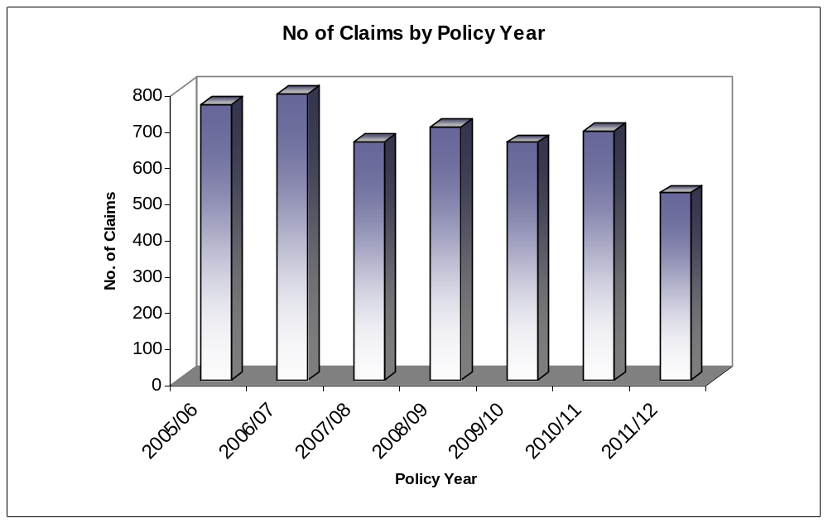

Chart 2

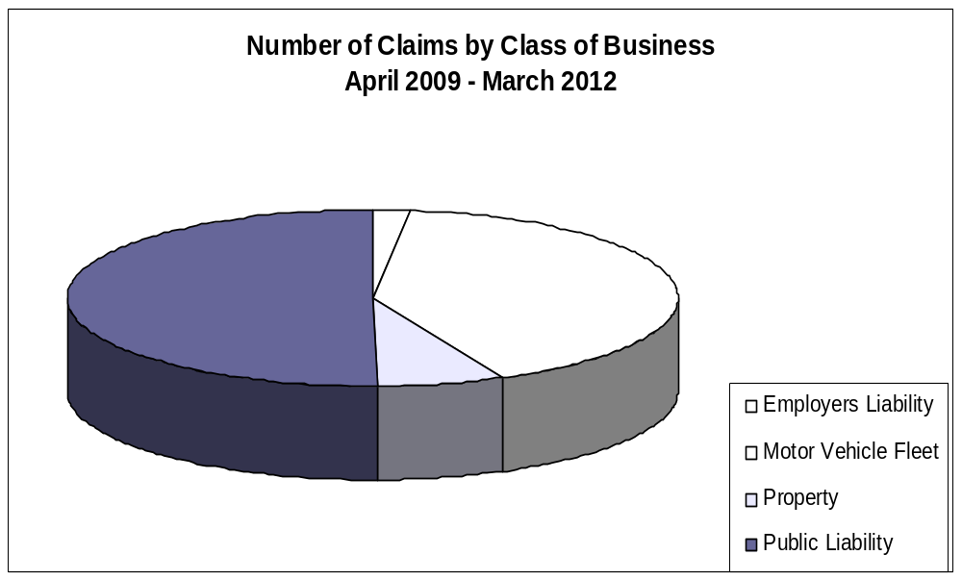

Chart 3

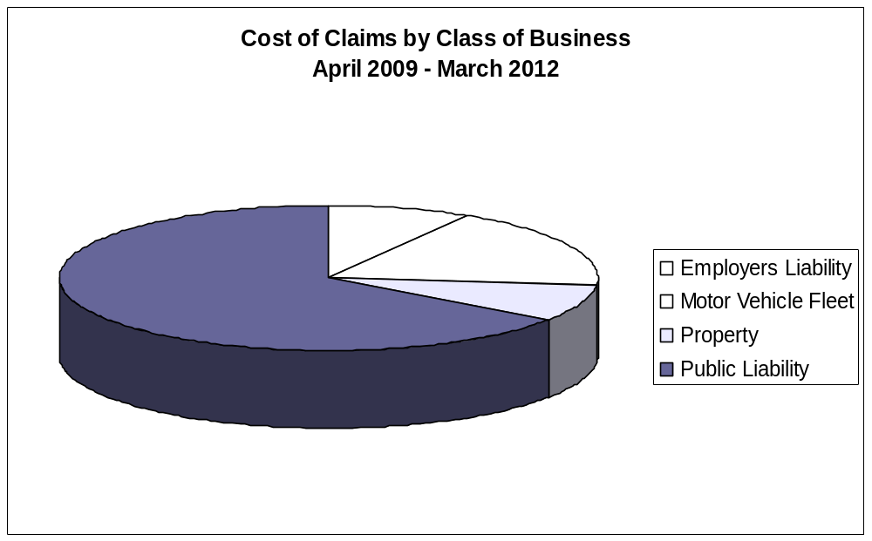

Chart 4

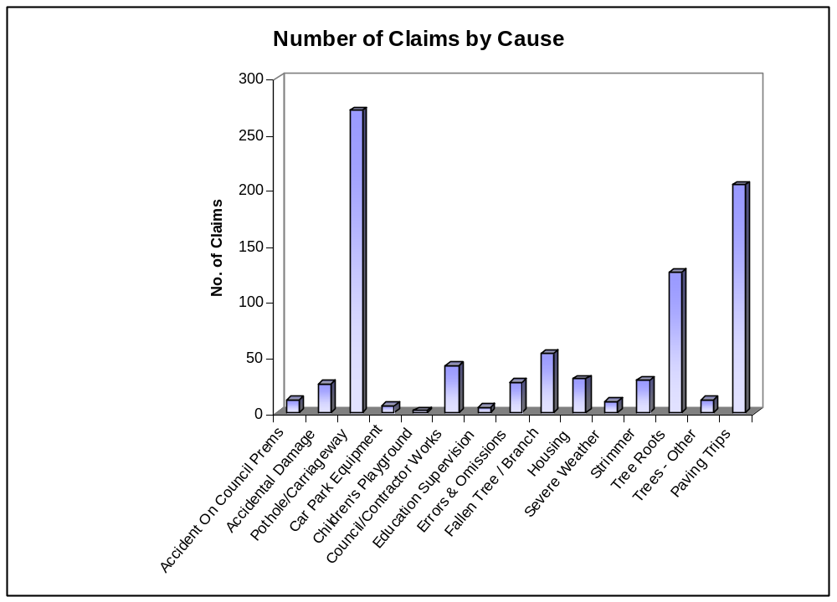

Chart 5



