REPORT FOR: | Pension Fund Committee
Date of Meeting: | 7 March 2017
Subject: | Local Government Pension Scheme Pooling Arrangements
Responsible Officer: | Dawn Calvert, Director of Finance
Exempt: | No
Wards affected: | All
Enclosures: | Appendix 1 – Letter from Minister for Local Government  Appendix 2 - Pensions CIV Sectoral Committee: London CIV 2017/18 Budget and MTFS

Section 1 – Summary and recommendations

Summary
The report updates the Committee on the development of the pooling arrangements and the London CIV and recommends that the Committee agrees a payment to the CIV in 2017-18 of £100,000 to cover the service charge (£25,000) and the development funding charge (£75,000).

Recommendations
The Committee are recommended to:
- Note the developments outlined in the report
- Agree the payment of £100,000 to the London CIV in 2017-18 as the Fund’s contribution to the running costs of the CIV

Section 2 – Report

- Introduction

- At their last meeting on 22 November 2016 the Committee received an update on pooling arrangements specifically:

- Update on funds “in the pipeline”
- Global equity procurement
- Harrow strategy
- CIV business plan

- Significant developments since that meeting have been:

- senior officers and members of the CIV met the Minister for Local Government on 12 December 2016 and the Chair of the Board of the CIV, Baron Kerslake, received a letter from the Minister dated 16 December 2016
- there has been a meeting of the Member-level Sectoral Joint Committee on 8 February together with seminars on fixed income/cashflow and stewardship.

- A copy of the letter from the Minister is attached as Appendix 1. The letter is the most current statement of the Government’s position on pooling and most of it appears to be applicable to all pools. However, one paragraph is clearly specifically directed at the London CIV and states as follows:

“However I note that on current forecasts the transition of assets into the London CIV pool will be unacceptably slow. In order to deliver greater scale and the full potential for savings, I expect the participating funds to work with you to ensure faster progress on transition, and I will review progress in the spring. As many of the participating funds have raised the issue with me, I must also underline that funds may not use multiple pools in order to access a preferred investment manager. Pools may of course procure services from other pools, especially where a particular asset class is not yet available. On that basis I am pleased to confirm that I am content for you to proceed as set out in your final proposal.”

There is a perception that the Minister’s concerns about the potential pace of transition arises from the number of funds included in the London CIV. This greatly exceeds the number in any other pool and comprises around one third of all the funds within the LGPS. Notwithstanding this, Harrow will need to bear the Minister’s concerns in mind.

- At their meeting on 22 November 2016 the Committee were advised of the most significant matters then exercising the CIV namely, funds “in the pipeline,” the position of “passive” mandates, the global equities procurement process and the CIV Business Plan and revenue streams.

- At its meeting on 8 February 2017 the Joint Committee considered a report entitled “Pensions CIV Sectoral Committee: London CIV 2017/18 Budget and MTFS.” This report provides an update of the main issues currently concerning the CIV and a copy is attached as Appendix 2. The matters highlighted in paragraph 4 above are all updated in this report.

- The inaugural conference of the CIV will be held on 1 March 2017 at which the Fund will be represented. Verbal feedback will be provided for the Committee.

- An update on the current Harrow strategy follows in Section B below:

- Harrow Strategy

- As at 31 December 2016 the Fund’s asset allocation was as follows:

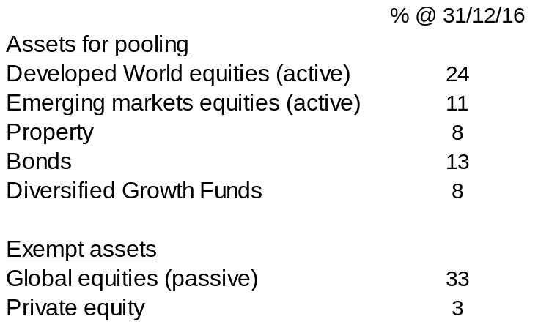

- The “launch plan,” included as Figure 1 on page 11 of Appendix 2, suggests that a sub-fund managed by Longview Partners will be launched in May 2017. It is understood informally that the fees will be reduced but the nature of this fund may be different from the Harrow current investment being unhedged and not suitable for a full “in specie” transfer. When details are received the Committee will be invited to decide whether it would be an appropriate investment for the Fund. If the Committee decides to invest, by the summer around 50% (albeit 83% of “poolable” mandates) of the Fund’s investments will still be subject to transition into the pool.

- Several global equities and fixed income mandates are scheduled for launch later in 2017 but, it is understood, that none of these are likely to involve any of the Fund’s current mandates. Details of the new mandates will be reported to the Committee as soon as notification is received and, so far as possible, will be available to Aon Hewitt as they review the Fund’s investment strategy.

- The Committee have previously been advised that, until recently, the business model of the CIV has assumed two major revenue streams – management fees on assets under management and borough service fees. Experience to date, as reported to the Joint Committee is that, since the CIV is receiving no income from passive equity funds, and there has been slower than anticipated fund opening, there is a significant shortfall in income. The Joint Committee and the CIV Board have agreed that in addition to the annual service charge of £25,000 charged to each borough they will need to charge a development funding charge of £75,000 in 2017-18 reducing to zero over the next 4-6 years. No official notification of this increase has yet been received but it is expected shortly and the Committee are recommended to agree a payment of £100,000 in 2017-18 with subsequent payments to be agreed as they are notified.

Financial Implications

- Whilst the pooling initiatives will have an impact on the costs and performance of the Fund the only financial implication arising from this report is the recommendation that the sum of £100,000 be paid to the CIV (£25,000 annual service charge and £75,000 development funding charge). This charge will be met from the Pension Fund.

Risk Management Implications

- The risks arising from the management and investment of funds are included in the Pension Fund risk register.

Equalities implications

- There are no direct equalities implications arising from this report.

Council Priorities

15. The financial health of the Pension Fund directly affects the level of employer contribution which then, in turn, affects the resources available for the Council’s priorities.

Section 3 - Statutory Officer Clearance

Name: Dawn Calvert |  |  |  | Director of Finance
Date: 21 February 2017
 |  |  |  | on behalf of the
Name: Caroline Eccles |  |  |  | Monitoring Officer
Date: 21 February 2017

Ward Councillors notified: |  |  | NO

Section 4 - Contact Details

Contact: Ian Talbot, Treasury and Pension Fund Manager 0208 424 1450

Background Papers – None.

