
H
Building on Success
Harrow YOT

Harrow Youth Offending Partnership

Youth Justice Plan

Update – August 2016

CONTENTS

Page Number |  | Appendices
Page 3 | Executive Summary
Page 4 – Page 10 | Youth Justice Plan
Page 11 – Page 21 | Annual Report | Appendix 1
Page 22 | YOT Board Membership | Appendix 2
Page 23 | Finance Table | Appendix 3
Page 24 | Staffing structure and breakdown | Appendix 4
Page 25 | Glossary of Terms | Appendix 5
Page 26 | Structure and Governance arrangements | Appendix 6
Page 27 | Structure Chart -Establishment | Appendix 7

Executive Summary
Joint Head of Service | In December 2015, a strategic decision was taken for the new permanent Head of Service for Early Intervention to take on the responsibility for the Youth Offending Team (YOT).
Restructure of Service | In 2015 the implementation of the new structure commenced, including recruitment of permanent staff.
Staffing | All existing posts within the structure have now been appointed to with the exception of the Part Time Restorative Justice Worker.
Representation at other panels | HYOT are represented and members of a number of panels, including MASE, Children Missing Meeting, Channel Panel, Wealdstone Youth Partnership.
Strengthening Preventative Services | Move of Triage function under Youth Offending Team as of January 2016  Increase in access to universal services and support for those identified within the household as “at risk” of offending by way of EIS redesign.
Charlie Taylor review of Youth Justice Services | Government review of Youth Justice Service could significantly impact the current delivery model. Report due to be published in September 2016.
Budget Reductions | HYOT have experienced a 10% in year budget reduction in 15-16 and a further 12% reduction in 16-17.
Move to new database | Migration of all data onto a new database has taken place, however there are still difficulties in embedding the new system and this is being monitored at every YOT board.
Assetplus | Introduction of new assessment framework is in progress.
Performance Reporting | Performance reports are available for scrutiny at YOT board, however there will be a shift in how reporting occurs in line with Assetplus framework. A proposal will be drafted and sent to board for endorsement in the coming months.
Priority YOT Status | HYOT are no longer considered a priority YOT based on improved outcome indicators

Our Vision
Creating a Safer Harrow and Positive Futures for Young People and Their Families.
Harrow Council Priorities
- Making a difference for the most vulnerable;
- Making a difference for communities;
- Making a difference for businesses; and
- Making a difference for families.
Local Safeguarding Children’s Board Priorities
- Refocus on core business: knowing that systems and practice are fit for purpose in identifying, assessing and responding to risk.
- Reduce vulnerabilities for young people in Harrow: to achieve a reliable understanding of the single and overlapping risks faced by young people in Harrow, so that preventative action is meaningful to young people and targeted action is based on sound local intelligence and national developments
- Actively incorporate the views of children and staff : ensuring that what we do and how we do it is accurately and regularly informed by the ‘Voice of the Child’ and the views of front line practitioners and their managers
- Effective collaboration: ensuring that the priorities of the HSCB are acknowledged and supported by other strategic partnerships within Harrow and that opportunities to work in collaboration with neighbouring LSCB’s are sought and initiated
INTRODUCTION
The Youth Justice Plan was endorsed for 3 years from 2015-2018 by the Youth Justice Board, the Youth Offending Management Board as well as the Local Authority Crime and Disorder Partnership (Safer Harrow), Cabinet and Overview and Scrutiny.
This is an updated plan for 2016-2017 and provides a detailed annual report of progress made.
Multi-agency Youth Offending Teams (YOT) were established in 2000 following the 1998 Crime and Disorder Act with the intention of reducing the risk of young people offending and re-offending, and to provide counsel and rehabilitation to those who do offend. The act stipulates the composition of the YOT and identifies statutory partners with the Local Authority as the Police, Probation and Health.
The Youth Justice Board (YJB) has set three outcome indicators for the Youth Offending Team;
• To reduce the number of First Time Entrants (FTE) to the Youth Justice System
• To reduce Re-offending
• To reduce the Use of Custody
There is a requirement that each local authority produces a Youth Justice Plan setting out achievements and plans for the future delivery of the service.
The prevention of offending and re-offending and anti-social behaviour by children and young people is a priority for all partners in Harrow, we believe this is best achieved through effective collaborative working. The Harrow Youth Offending Team (HYOT) sits within the Peoples Directorate in the council. The Youth Offending Team is therefore represented throughout children’s services strategic and operational groups and influences strategic planning for children and young people who offend or are at risk of offending.
The Youth Offending Team (YOT) engages in a wide variety of work with young people who offend (those aged between 10-17 years) in order to achieve the three outcome indicators. The Youth Offending Team supervises young people who have been ordered by the court to serve sentences in the community or in the secure estate, and provides a range of interventions to help young people make effective and sustainable changes to prevent them from further offending.
The governance of the YOT is through line management accountability to the Corporate Director of Peoples Services and the Harrow Youth Offending Partnership Board, which is accountable to the Safer Harrow Partnership.
The strategic aims for the YOT are:
• Effective delivery of Youth Justice Services
• Positive outcomes for children and young people who offend or are at risk of offending through effective partnership arrangements between the Youth Offending Team statutory partners and other stakeholders
• Efficient deployment of resources to deliver effective Youth Justice systems
An Annual Report is provided as an appendix to this YJ plan (Appendix 1). This offers detailed information on the overall progress made over the past year in all aspects of delivery of youth justice services including key achievements and challenges and any innovative practice.
STRUCTURE AND GOVERNANCE
Effective governance, partnership and management are in place (see Appendix
Through the role of Corporate Peoples Director and Divisional Director Harrow YOT is represented at the following Boards and Forums
- Harrow LSCB
- Safer Harrow
- Health and Well Being Board
- Together with Families Strategic Board
Safer Harrow is the local Crime and Disorder partnership and holds strategic responsibility for crime and disorder issues within Harrow. The membership consists of the following statutory partners
- London Community Rehabilitation Company
- MOPAC
- Police
- London Fire Brigade
- Harrow Childrens Services
- Environmental Health (Public Protection)
- Community Safety/Crime reduction and Health
- National Probation Service
The Youth Offending Partnership Board provides strategic direction with the aim of preventing offending by children and young people. The role of the Board is to;
• Determine how the YOT is composed and funded,
• How it is to operate and what functions it is to carry out
• Determine how appropriate youth justice services are to be provided and funded
• Oversee the formulation each year of a draft youth justice plan
• Oversee the appointment or designation of a YOT manager
• As part of the Youth Justice Plan, agree measurable objectives linked to key performance indicators, including the National Standards for Youth Justice.
All statutory partners and the voluntary sector are represented on the Board at the appropriate level o seniority. The Board is chaired by the Divisional Director for Children and Young Peoples Services. (Membership of the Management Board is noted in appendix 2)
The Youth Offending Partnership Board meets every 6 weeks, receives national and local performance data and reports of relevant issues affecting the YOT and partners.
The Youth Offending Management Team oversees the development and implementation of the Youth Justice Plan, considers resource and workload issues, finance, performance and data reporting, and the implementation of policies and procedures.
The positioning of the Youth Offending Team with governance and accountability through Safer Harrow, and line management within Peoples Directorate enables the YOT to meet its dual strategic functions relating to both justice and welfare.
The Board receives regular performance reports and a yearly financial report. The reports enable the Board to monitor compliance with grant conditions and timely submission of data. The Board also receives national and local data to support the understanding of offending trends, allowing the effective allocation of targeted resources. The Board will continue to be informed about compliance with secure estate placement information, the outcomes of the annual National Standards audit and any Community Safeguarding and Public Protection (CSPPI) notifications.
RESOURCES AND VALUE FOR MONEY (PARTNER CONTRIBUTIONS)
Harrow’s YOT (HYOT) is resourced by contributions from Harrow Council and statutory partners. The YJB good practice grant now accounts for delivery of unpaid work and expects YOT to demonstrate a continued commitment to Restorative Services within the grant funding allocated. Grant funding is allocated to providing services which achieve the three outcome indicators. This includes:
- Part funding of Cahms Practitioner
- Goldseal Enterprise Project (Intervention)
- Delivery of unpaid work
- Staffing costs
In addition HYOT are commissioning providers to support in the implementation of Assetplus and any associated technical upgrades.
HYOT spot purchase spaces with local charity organisation Ignite to assist in the delivery of unpaid work and are committed to embedding Restorative practice across the service.
Valuable partnership resources have remained, with little change. This has supported the YOT in managing financial cuts to the Good Practice Grant, both in year and for the new financial year of 16-17. (Please see Appendix 3 for finance table).
HYOT have restructured their service and since April 2016 have a fully permanent workforce including a permanent Head of Service with the exception of the part time Restorative Justice Coordinator post which is due to be advertised in due course. Please see Appendix 4 for structure chart and staffing breakdown of ethnicity and gender.
The Youth Offending Team has recruited 9 volunteers who undertake duties as Referral Order Panel members. They have all undergone Panel Matters and Restorative Justice Training. It is a statutory responsibility to provide a community panel for young people who have been sentenced to a Referral Order by the courts. Recruitment remains open as we are keen to increase our pool of volunteers. In addition, the RJ Coordinator is an RJC accredited practitioner. We are currently in the process of identifying training for her line supervisor to also become accredited to ensure requirements as outlined by RJC council are being met.
PARTNERSHIP ARRANGEMENTS
The YOT partnership ensures that the YOT is strongly linked to other planning frameworks. As stated earlier the Youth Offending Management Board reports to Safer Harrow and feeds into the development of a strategic approach to Crime and Disorder.
Police
Resource levels have remained consistent from partners with a good commitment from the Police securing 2 FTE police officers within the YOT.
Mental Health
The government’s report Healthy Children, Safer Communities highlighted the significant health challenges faced by young people involved in the criminal justice system. These challenges can often be drivers of offending and offer an important opportunity to support the welfare of these vulnerable young people
The mental health post (clinical nurse specialist) is jointly funded by Harrow CCG and the Youth Offending Team. This has historically been for 2 days a week with a rolling contract year on year. However both parties agreed to increase provision to 3 days a week and have now agreed a 3 year contract till 2018.
This provides the YOT with the opportunity to embed the role within the YOT; ensuring young people have access to sustainable provision throughout the duration of their court order, and supporting referral pathways to higher tier intervention.
Probation
Although probation were unable to provide a Probation Officer from Feb 2015 onwards, a local agreement was made between YOT and Probation Services to invoice the cost of an agency worker to Probation. This supported ensuring caseload numbers remained at a manageable level.
Despite significant changes within the Probation Services, and resources being reviewed, HYOT has retained one FTE Probation Officer. HYOT was successful in the appointment of a secondee who commenced post on 8th June 2016. This will continue to support the delivery of specialized work such as taking the lead on MAPPA, transitions from YOT to Probation, and will be a key role in the Integrated Offender Management scheme.
Substance Misuse
The Local Authority continue to have wider commissioning arrangements with Compass as providers of substance misuse services for young people in Harrow. HYOT has an allocated worker who is based within the team 4 mornings a week. The links with compass services remain strong, as the view is this supports transitional arrangements to community services if continued support is needed post the completion of the statutory order.
Court
There are systems in place to ensure good communication with the courts through attendance at the Court User Group and the North West London Youth Panel Meetings. Court representation and attendance at the YOT Board has been most helpful in ensuring a solution-focused approach to raising standards, and although the chair of the panel has changed, the previous chair continues to attend the YOT board to offer consistent support and appropriate scrutiny.
HYOT continue to deliver training to magistrates to assist in understanding the role of the YOT when completing PSR’s and provide data on a quarterly basis regarding court throughput and offending trends.
Youth Justice Liaison and Diversion (YJLD)
The YJLD role now sits within the YOT and provides mental health screenings for all young people at point of arrest. A steering group consisting of LA, YJB –NHS rep, Police and other partners oversees the work and supports in the identification of local trends.
Early Intervention Service
In light of public sector funding cuts, there has been a need to redesign how prevention services are offered within the LA. This has resulted in the realignment of YOT alongside EIS and Children’s Centres with a shared Head of Service overseeing the service areas. The redesign of the Early Intervention Service is aimed to strengthen prevention services for those identified as at risk of offending, and improve access to services at the earliest possible opportunity and encouraging sustained pathways into universal services within the community and supporting a whole family approach. The timeline for implementation of the redesign is November 2016.
Commissioned Services
The Goldseal music provision continues to support the YOT in providing quantitative outcomes by way of academic qualifications, as well as providing a creative way to assist engagement in statutory court orders. Goldseal has continued to provided outcomes for young people by using music, production and enterprise skills as a way of encouraging self-confidence, team building. It provides a platform for young people to express their emotions in creative ways by writing / recording lyrics in a local Youth Centre. This also exposes the Young People to other services which may be accessible at the Youth Centre, promoting community engagement.
Harrow School / Tallships Youth Trust
The Tall Ships Youth Trust, is a registered charity founded in 1956 dedicated to the personal development of young people through the crewing of ocean going sail training vessels. It is the UK’s oldest and largest sail training charity for young people aged 12-25.
Harrow School is one of Britain's leading independent schools, specialising in providing a high quality boarding school education for boys.
Due to the success of the previous year the partnership board endorsed a further activity for 2016, enabling a group of ten young men from Harrow School and ten young men known to YOT to undertake a week long Tall Ships challenge.
Other Partners
HYOT continue to work closely with the transformational lead for Troubled Families termed “Together with Families”. Work is on-going in respect of identification and screening of these families who meet the criteria for the Troubled Families cohort. The project has funded one permanent worker to deliver triage services, supporting reducing young people entering the criminal justice system and ensuring they are effectively diverted away
HYOT are members of the MASE panel and contributed to the Gangs Peer review which took place in Harrow in early 2016. The YOT also has an identified CSE champion within the service and are actively engaged with the Violence, Vulnerability and Exploitation team, a member of which also sits on the YOT Risk and Vulnerability Management Panel.
HYOT continue to have low numbers in custody, and will continue to offer alternatives to custody as a preferred option to courts. Where young people have been in custody HYOT have utilised ROTL (Release on Temporary licence) to support young people in accessing provisions such as Princes Trust to increase their skill set and employability. In addition we work closely with resettlement provisions within custodial facilities to ensure young people are clear on pathways and have focussed exit strategies in place. HYOT also sits alongside other Children Services providers, so are able to have access to provisions such as “Access to Resources Panel”, where cases are presented to senior managers to secure outcomes, this can range from therapeutic input to specific accommodation types.
The Counter Terrorism and Security Act 2015 came into effect in February 2015. This places a duty on specific organisations to have due regard to the need to prevent people being drawn into terrorism. The duty came into force from the 1st July 2015. Local authorities are among the key agencies vital to prevent young people from being drawn into terrorism and YOT’s have an important role to play. As a direct result of this the YOT became a core member of the Channel Panel which is also chaired by YOT Head of Service. All staff have undergone prevent training and have made referrals to Channel Panel as well as requesting bespoke support from PVE coordinator if a young person has not met the threshold for panel, but concerns remain.
In addition to this there is a regular YOT representative at the Anti-Social Behaviour Action Group (ASBAG) to ensure information is shared across agencies from a wider perspective.

RISKS TO FUTURE DELIVERY AGAINST THE YOUTH JUSTICE OUTCOME MEASURES
Funding continues to raise concerns regarding the effective delivery of youth justice services. A mid year cut of 10% in 15-16, followed by a 12% reduction in grant funding for 16-17 has caused considerable pressure in supporting the current arrangements in achieving outcomes. Despite partner contributions remaining relatively stable, there is concern that the future of services within the public sector are volatile and any small changes to resource could significantly impact delivery of Youth Offending services. Intense and varied resources are needed to reduce reoffending of the most complex cohorts that continue to present themselves within the Criminal Justice System.
HYOT are currently in the process of updating their self-assessment and it is aimed to be presented at the YOT management board in September for sign off. HYOT are also part of the wider council’s quality assurance framework and commit to auditing 3 cases a month in addition to quality assuring all initial assessments and PSR’s. The quality assurance framework is in the process of being revised and updated in light of changes to the National Assessment Framework and the introduction of the Assetplus.
Assetplus is a new assessment and planning interventions framework developed by colleagues at the Youth Justice Board (YJB) which replaces the current Asset framework. It has been designed to provide a holistic “end to end” assessment and intervention plan, allowing one record to follow a childs’ journey throughout their time in the criminal justice system.
Harrow are amongst the last group of YOT’s who are in the process of implementing this within their case management system (Capita One Youth Justice) as well as ensuring staff have robust support and training in use of the revised assessment tool.
The roll out of this revised assessment framework is multi-faceted and requires technical support from local IT providers, Capita One Youth Justice as well as training for staff through modules on Youth Justice Interactive Learning Space (YJILS) completed individually and practical group training for all staff.
There could be a significant impact on timeliness of assessments and quality of practice whilst Assetplus is being embedded within the service. This is being monitored and reported to at every YOT board to ensure there is minimal disruption to services being delivered.
The Government review of Youth Justice Services (Charlie Taylor Review) is currently underway with a report due to be published imminently. It is anticipated that this will have significant implications on service delivery, which would need to be considered on publication. In light of the Charlie Taylor Review, there is a suggestion that devolution is a possibility in respect of the delivery of Youth Justice Services. Local implications of this could mean the absorbing of statutory function of YOT into wider Childrens Services. HYOT are considering alternative models of delivery and are aligning its on statutory functions to the wider Youth Strategy.

Appendix 1 – Annual Report
Harrow Youth Offending Team Annual Report 15-16

This annual report provides detailed information on the progress made over the last year in relation to addressing youth offending trends in Harrow and the performance of the Youth Offending Team (YOT). In addition the report considers priorities for the service for the forthcoming year 16/17.

Our Vision
Creating a Safer Harrow and Positive Futures for Young People and Their Families.
Overview

The Harrow Youth Offending Partnership Youth Justice Plan, set the following key priorities for 15/16
- Reduce youth reoffending and the use of custody and remands
- To support the delivery of the Troubled Families (Together With Families) agenda
- To ensure that Looked After Children known to YOT have the best life chances
- To respond to Child Sexual Exploitation
- To ensure risk of harm / reoffending, planning and interventions are of high quality and produce good outcomes
- To ensure compliance with Working Together and the work of the Harrow LSCB.

Key challenges in the last year have included:
- Integration of a new database
- Recruitment of permanent staff to the revised model of delivery
- Financial constraints impacting on resources to support reduction in reoffending
- Move of Out Of Court Disposals under the remit of Youth Offending Team

Youth Crime

Overall youth crime continued to show a year on year decrease. However 2015/16 has seen an increase in the numbers of young people committing crime, 132 compared to 105 the previous year.
2015/16 has also seen a change in the distribution of disposal types being issued. The most notable change is a decrease in the proportion of Referral orders (first tier disposals), with 50.8% compared to 64.3% for the previous year and an increase in the proportion of Youth Rehabilitation Orders (community disposals), with 36.9% compared to 22.1% for the previous year. This could be attributed to the change in Out Of Court Disposals which allows police the opportunity to deal with a wider range of offences outside of a court process, whilst still ensuring there is a substantive outcome in relation to the offence. Factors such as admittance of guilt and levels of remorse are taken into account when considering these options.
National Data – YJB

Harrow YOT continues to have comparably good results for custody rates with a decrease of 0.21 and a current rate which is lower than National, London and YOT family comparators.

First Time Entrants have increased by 20.3% in the latest reporting period (14-15).

A National Standards Audit conducted in September 2015 identified a need to make significant improvements in relation to Preventing Offending (National Standard 1) which has a direct impact on First Time Entrants. Since January 2016, the prevention arm of the YOT (Triage) function has moved under the management of the YOT service (from the Early Intervention Service). Performance issues have been managed to ensure all young people who are subject to Triage intervention receive an assessment and needs based intervention. The audit also identified under National Standard 2 (Out of Court Disposals) standards were met, demonstrating further evidence to align all functions under the YOT, as Out of Court Disposals were already being managed by the YOT. The current redesign of the Early Intervention Service continues to focus on strengthening preventative services within the YOT which will assist in reducing the number of First Time Entrants and support to improve this outcome indicator.

Re-offending remains a challenge with the latest figure showing a 1.2% increase on the previous year, which comes in higher than National, London and YOT family averages. Increased reoffending rates continue to be a national issue across Youth Offending Services and on-going analysis demonstrates the complexity of this cohort, which include significant welfare related factors contributing to repeat offending.

 | Harrow | London | YOT Family | England
FTE PNC rate per 100,000 of 10-17 population **Good performance is typified by a negative percentage
Oct 14 - Sep 15 (latest period) | 379 | 419 | 320 | 376
Oct 13 - Sep 14 | 315 | 428 | 310 | 426
percent change from selected baseline | 20.5% | -2.0% | 3.2% | -11.8%
Use of custody rate per 1,000 of 10 -17 population **Good performance is typified by a low rate
Jan 15 - Dec 15 (latest period) | 0.21 | 0.67 | 0.37 | 0.40
Jan 14 - Dec 14 | 0.43 | 0.75 | 0.45 | 0.44
change from selected baseline | -0.21 | -0.08 | -0.8 | -0.04
Reoffending rates after 12 months
Re-offences per offender - Apr 13 to Mar 14 cohort (latest period) | 2.59 | 3.00 | 2.82 | 3.13
frequency rate - Apr 12 - Mar 13 cohort | 2.50 | 2.79 | 2.66 | 2.99
change from selected baseline | 3.7% | 7.8% | 6.0% | 4.7%
frequency rate - Apr 13 to Mar 14 cohort (latest period) | 1.15 | 1.31 | 1.17 | 1.19
frequency rate - Apr 12 - Mar 13 cohort | 1.08 | 1.16 | 1.04 | 1.08
change from selected baseline | 6.6% | 12.6% | 12.7% | 10.2%
Binary rate - Apr 13 to Mar 14 cohort (latest period) | 44.4% | 43.5% | 41.6% | 37.9%
binary rate - Apr 12 - Mar 13 cohort | 43.2% | 41.6% | 39.2% | 36.0%
percentage point change from selected baseline | 1.2% | 1.8% | 2.5% | 1.9%

The below graphs show YJB data in comparison to Harrow’s “YOT Family” against the following three outcome indicators: Reducing First Time Entrants, Reducing Reoffending and Reducing the use of Custody.

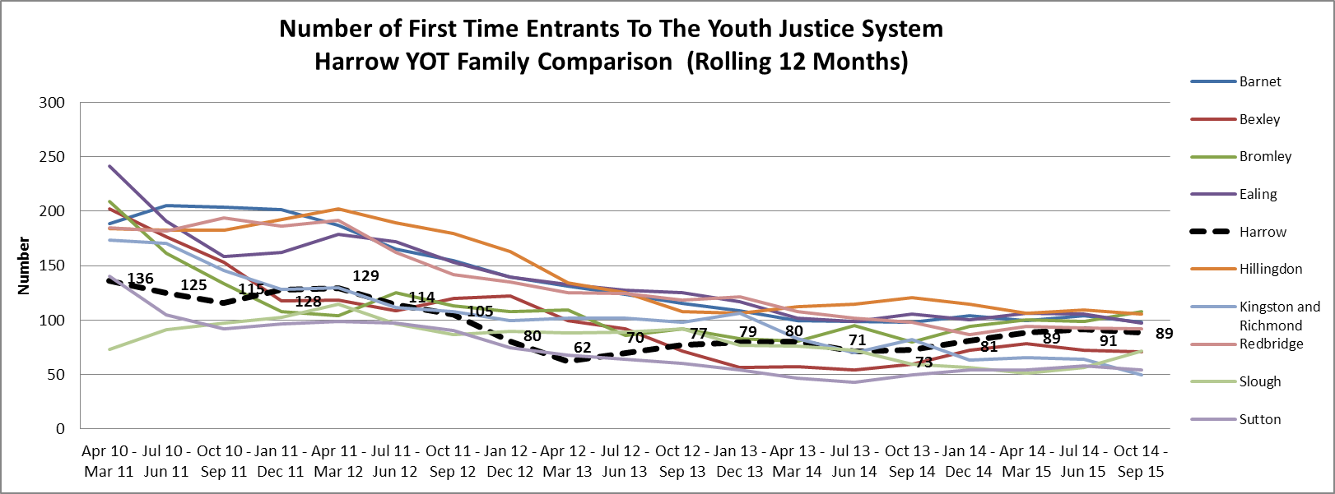

Between 2010/11 and 2013/14 there had been a steady year on year decrease in the number of first time entrants to the Criminal Justice System, which is reflective of national and statistical neighbour trends. However, Harrow has seen an increase of 20.3% in First Time Entrants in the latest reporting period (Oct 2014 - Sep 15) with 89 individuals compared to 73 in the previous year (Oct 2013 – Sep 14). This change is not reflective of the national picture, where there has only been a small increase in the YOT family average (3.2%) and a continued decrease in the National average (11.7%). The rate per 100,000 has increased for Harrow in the latest reporting period (Oct 2014 - Sep 15) with 379 compared to 315 in the previous year (Oct 2013 – Sep 14). The current rate is now higher than YOT family averages (320) and slightly higher than National averages (376).

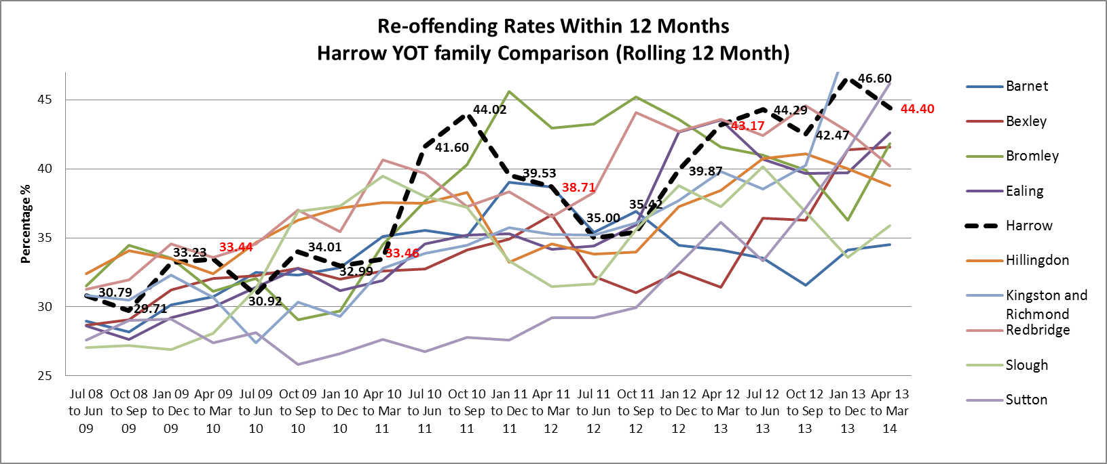

The YJB official Re-offending statistics operate at a lag with the latest available reporting period for Apr 13 – Mar 14.

Within the YOT family data shows an increase in Re-offending. This upward trend is also reflected across London and National figures and is a recognised area for improvement across youth justice services and partnerships.

In the latest reporting period (Apr 13 – Mar 14) the Re-Offending Rate is at 44.4% bringing Harrow to the 3rd highest in the YOT family. This rate is higher than the National average (37.9%), the London average (43.5%) and the YOT family average (41.6%). The increase for Harrow compared to the same period last year (Apr 12 – Mar 13) is 1.2% which again is reflective of the national picture.

Harrows most recent Re-offending rate accounts for 71 re-offenders from a cohort of 160. The size of the cohort and the number of re-offenders have decreased consistently over time, with exception of the last 3 quarters where there has been a notable rise to 160 compared to 140 three quarters ago. The numbers of re-offences has also started to increase in the last few quarters from 60 during the same period in the previous year (Apr 12 – Mar 13) to 71 in the current quarter.

The alternative measure for Re-offending is the frequency rate which measures the average number of re-offences per re-offender rate. In the latest reporting period (Apr 13 - Mar 14) the average number of offences committed by reoffenders was 2.59.

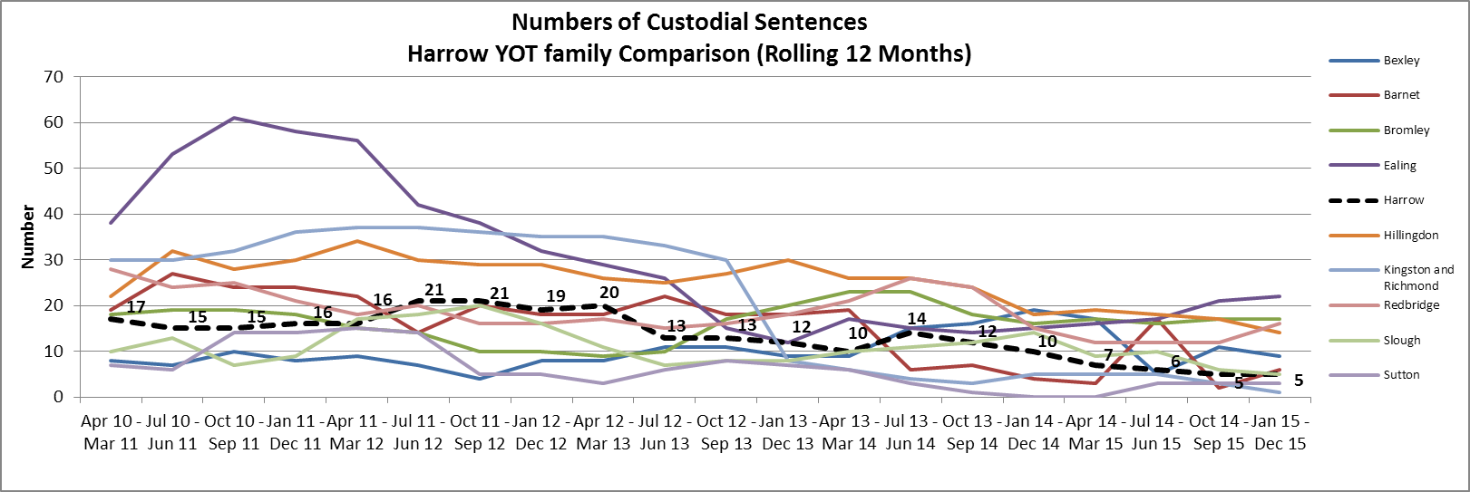

Over the past 3 years, Harrows numbers in custody have been varied, ranging from 5 and 21 in any 12 month rolling period. The last quarter continues to show a significant decrease in figures with only 5 custodial sentences for the latest 12 month rolling period (Jan 15 - Dec 15). Harrow's current figure of 5 (Jan 15 - Dec 15) compares to 10 (Jan 14 - Dec 14) for the same period in the last year and is the lowest it’s ever been for Harrow.

The custody rate per 1,000 indicators allows for a better comparison between YOT's performance. Overall, Harrow's latest position (Jan 15 - Dec 15) of 0.21 is the 3rd lowest and is lower than National average (0.40), London average (0.67) and YOT family average (0.37).

LOCAL DATA

Use of Custody

Annual Numbers in custody April – March | 2012/13 | 2013/14 | 2014/15 | 2015/16
Total custodial sentences open at the start of the year | 8 | 13 | 8 | 3
Total custodial sentences starting in the year | 20 | 10 | 7 | 7
Total in custody during year | 28 | 23 | 15 | 10
Rate per 100,000 | 0.84 | 0.42 | 0.30 | 0.30

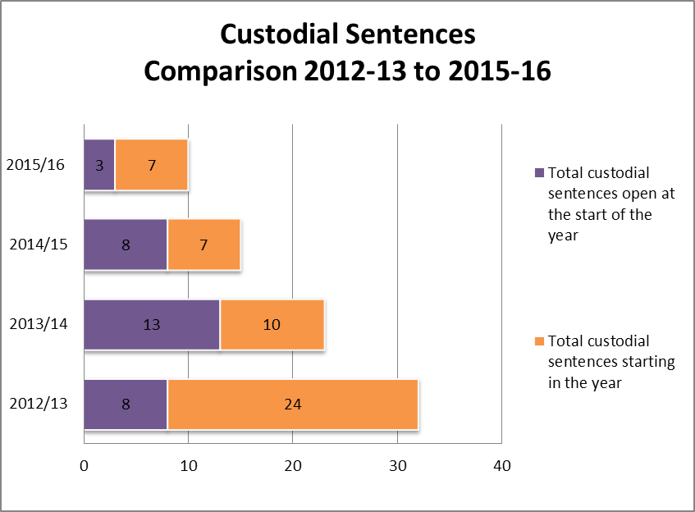

Over the past 3 years harrow has seen considerable decreases in custodial sentences, from 28 in 2012/13 to 23 in 2013/14 and 15 in 2014/15. At the start of 2014/15 Harrow had 3 young people on custodial sentences, there have been a further 7 new custodial sentence's during the year.

Use of Remand

Annual Remand Figures April - March | Remand Episodes | Remand Bed Day's
2015-16 | 12 | 398
2014-15 | 4 | 357
2013-14 | 13 | 311
2012-13 | 17 | 801

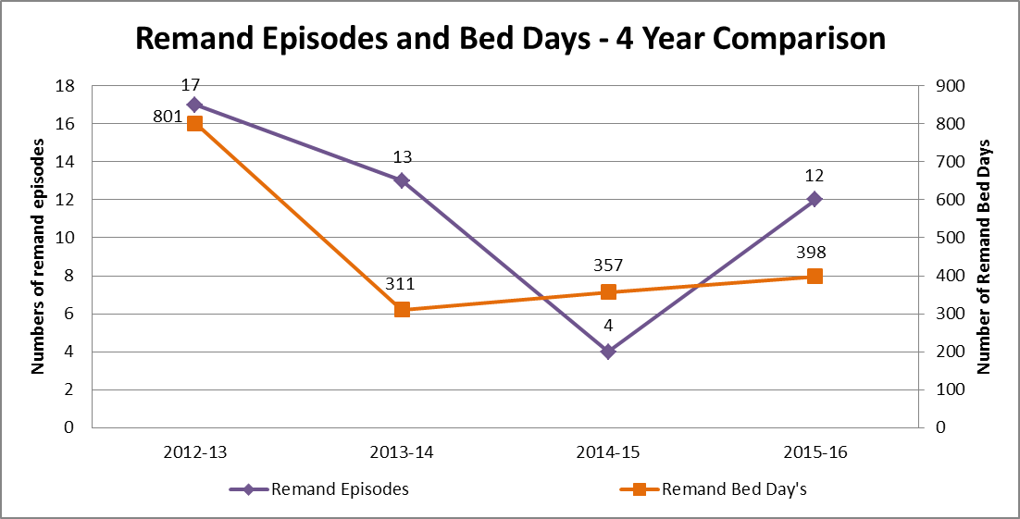

There was a significant dip in those remanded in 2014-15 however this has increased again in 2015-16 to 12 young people. This accounts for two cases that were already open at the start of the year and 10 new remands starting in the year. Although the increase of 10 remands is of concern, further analysis showed the following outcomes for the young people:

- 1/10 is still subject to a remand status
- 4/10 went on to receive a custodial sentence
- 2/10 were sentenced as adults
- 2/10 were released on bail during the remand period and went on to receive robust community sentences
- 1/10 received a community proposal on sentence

All of these offences were considered serious and crossed the legal threshold of receiving custodial sentences. It is positive to note that despite being remanded, post a thorough assessment HYOT were able to offer robust bail support to two cases. This then led to community disposals demonstrating a confidence from sentencing courts in HYOT’s ability to ensure the public are protected whilst managing high risk cases within the community. In addition those where custodial sentences were received the offences were deemed so serious, that despite robust community proposals being offered, magistrates felt custody was the only option.

Data Summary – Outcome Indicators

FTE - From Oct 2014 - Sep 15, compared to the same reporting period of Oct 2013 – Sep 14; HYOT have an increase of 20.5%, which accounts for 16 more young people entering the system. However the latest reporting period although demonstrates an increase, does account for less young people. The reporting period from January 2014-December 2014 showed 82 young people identified as FTE’s, and in January 2015- December 2015 accounted for 86 young people as FTEs. The latest reporting period shows there was an increase, but at a lesser rate of 4 young people.

Reoffending – There has been a national increase in reoffending rates, and HYOT figures also demonstrate an increase (although at a lesser rate than national averages). The cohort from July 2013 – June 2014, demonstrates that 66 young people (who reoffended) are responsible for 185 offences, which is an average of 2.8 offences each. This is an increase of 0.6% from the year before. Further analysis of this cohort will continue to take place to assist in understanding trends and informing future resource allocation.

Use of Custody – HYOT has consistently demonstrated a reduction in the use of custody despite working with more serious offending. This evidences an increased confidence from courts, in HYOT’s ability to safely manage complex cases within the community. HYOT’s latest position of 0.21 is a significantly lower custody rate than the national average of 0.40

ETE

Current ETE for Open Interventions
Actively engaged in ETE | Total In Age Group | Total Actively Engaged | % Actively Engaged | Engaged in ETE for less than standard Hrs. | % Engaged in ETE for less than standard Hrs. | Total NEET | % NEET
Statutory School Age (25+ Hrs. ETE) | 35 | 26 | 74.3% | 5 | 14.3% | 4 | 11.4%
Non Statutory School Age (16+ Hrs. ETE) | 36 | 18 | 50.0% | 1 | 2.8% | 17 | 47.7%
Total | 71 | 44 | 62.0% | 6 | 8.5% | 21 | 29.6%

Rates for young people in Education, Training or Employment (ETE) have been variable over the year. Harrow’s local target is 75%. The most recent ETE figure which represents the current ETE status of the open caseload (End March 2016) is displayed in the table above and is 62.0%, this compares to 64.0% at the same point in the previous year (End March 2015). The focus on ETE is reflected in the structure of the YOT, where a full time education specialist has been appointed (April 2016) to assist in prioritising education for those in the criminal justice system.

Ethnicity and Gender

Due to Harrow’s unique demography, it is difficult to make comparisons to National and London averages for the ethnicity of young offenders. Thus, all ethnicity comparisons are made against the local demographic make-up of the 10-17 year old population.
Asian/Asian British makes up 41.1% of Harrow’s 10-17 population, yet accounts for 15.3% of the young offending population in 2015/16. Asian/Asian British have been consistently under represented over the past 5 years, but have fallen to the lowest yet in 2015/16
Young people of Mixed Ethnicity make up 8.8% of Harrow’s 10-17 population. This rate had been relatively stable over the past 4 years and 2015/16 is the first time there has been a significant increase in the offending population.
2013/14 and 2014/15 had seen a decrease in the proportion of white young people, bringing it back in line with the local average. In 2015/16 with an increase to 39.7%, meaning that the white population is now over represented in youth offending services.
The most notable difference between local demographics and youth offending demographics can be seen in the Black/African/Caribbean/Black British group. This group are considerably over represented, making up only 12.9% of Harrow’s 10-17 population but 28.2% of the youth offending population in 2015/16. Over the past five years this group have been consistently over represented in youth offending services but the figure has been falling over the past two years since 2013/14 with 32.4% in 2014/15 and 28.2% in 2015/16.
Over the past 5 years harrow’s figures have been variable between 13.4% female to 17.1% female. The 2015/16 breakdown is 15.9% females (21) and 84.1% Males (111). Harrow has a lower proportion of females convicted of an offence (15.9%) compared to the National Average (17.8%).
Internal Performance Measures

Internal performance measures continue to be reported on, however there was a significant gap in performance monitoring from August 2015 to February 2016. This was due to a database migration from YOIS to Capita One Youth Justice and affected the timeliness of paperwork and case notes being recorded onto the system.

There have been on-going concerns regarding the new database both from a technical and performance perspective. (Details of impact on service delivery are provided in section headed “IT and Assetplus”).
A dip in performance during Q3, linked to a lack of performance reporting has had an impact on the full year figure, and demonstrates an overall decrease in all performance indicators

In addition, the restructure of the service also took place which also affected the timeliness of performance. The YOT experienced some significant transitions from agency to permanent staff who were then expected to reassess cases and complete relevant paperwork. These combined issues caused significant disruption to the performance management of the service.
Weekly performance reports are now available and monthly reports continue to be shared with YOT Partnership Board which offers appropriate challenge and oversight to ensure timeliness of performance improves.

Target | Description of Measures/Indicators | Q4  2014-15 | Full Year Figure  2014-15 | Q1  2015-16 | Q2  2015-16 | Q3  2015-16 | Q4  2015-16 | Full Year Figure  2014-15 | Q4 comparison between 2014/15 and 2015/16 | Full year comparison between 2014/15 and 2015/16
1 | % ASSETS Completed within 15 days (20 days for referral orders) | 90.9% | 90.7% | 78.1% | 75.8% | 70.4% | 56.5% | 73.4% | -34.4% | -17.3%
2 | % Interventions with Plans completed within 15 working days (Referral Orders - 20 days) | 59.4% | 72.4% | 57.1% | 76.9% | 35.0% | 33.3% | 53.5% | -26.1% | -18.9%
3 | % ROSH's (Risk of Serious Harm Assessment) that were countersigned in period | 94.0% | 90.3% | 59.3% | 93.3% | 71.4% | 65.0% | 69.4% | -29.0% | -20.9%
4 | % Risk Management Plans (RMP) and Vulnerability Management Plans (VMP) countersigned in period | 83.3% | 91.9% | 56.8% | 61.5% | 60.6% | 66.7% | 61.9% | -16.6% | -30.0%
5 | Of those appropriate for Home Visits, % having them within 28 days of the intervention start | 67.9% | 74.0% | 56.0% | 52.8% | 31.8% | 61.1% | 50.5% | -6.8% | -23.5%
6 | What do you think forms - Proportion of current caseload having a what do you think form? (proportion of start ASSET's having a what do you think form) | 75.9% | 87.5% | 29.6% | - | - | - | - | Data not available | Data not available
7 | Education Training & Employment - Proportion of young offenders who are 'Actively engaged' in education, training and employment (ETE) currently. Based on current caseload (25+hrs for statutory school age and 16+ hrs for 17-18 year olds) (This does not include those in custody or on remand) | 64.7% | 64.70% | 69.9% | - | - | 60.3% | 60.3% | -10.9% | -4.4%

Caseloads / Intensity Levels

In 2015 / 2016 there has been an overall increase in the number of interventions starting in the year (139) compared to the previous year (119). The below graph shows the assessed levels of intensity at the start of the intervention. (Assessed levels of intensity determine the minimum number of contacts a young person has as part of their court order). Although there was not a significant shift in those assessed as “intensive” (requiring the most amount of contact), there was an increase in those assessed as “Enhanced” at the start of the order demonstrating an increase in the complexity of cases entering the Youth Justice System.

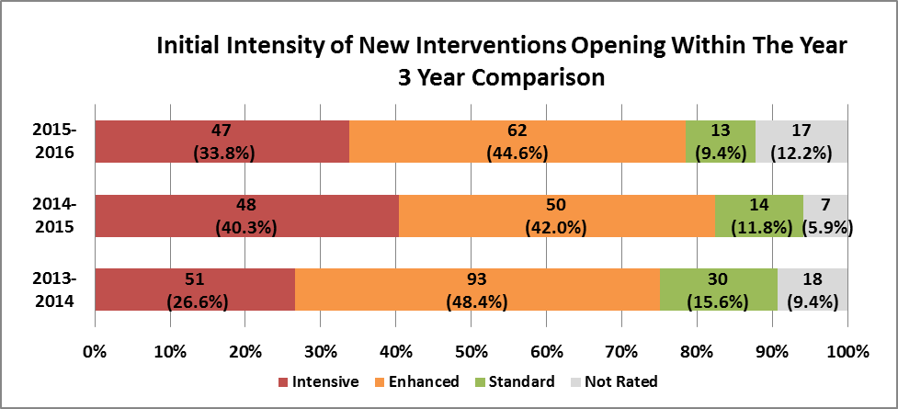

In addition assessed levels of Vulnerbility has shown a notable increase in those assessed as having very high/high vulnerability with 5 (4.8%) cases assessed as having very high vulnerability and 18 (17.1%) cases assessed as having high vulnerability. There is a significant decrease in the numbers having low vulnerability with 31 (29.5%) in 2015/16 compared to 38 (40.0%) in 2014/15. Again this demonstrates that the YOT are robustly identifying and assessing levels of vulnerbility from the onset. See below table:

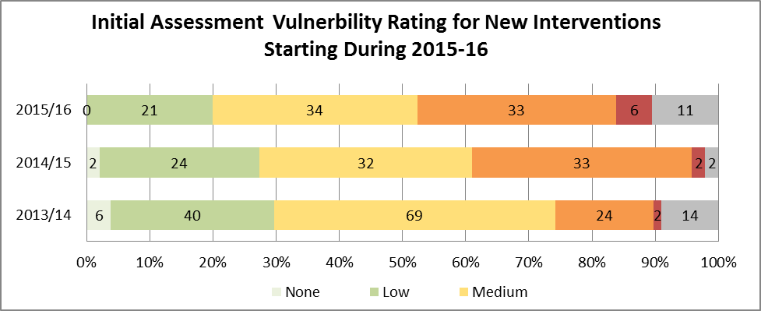
YOT and Looked After Children

A snapshot of the YOT current caseload in May 2016 shows that there were a total of 12 young people who were looked after, this represents 13.3% of the YOT caseload. A total of 33 young people were classed as Children In Need (36.7%), and 5.6% were subject to Child Protection Plans. Of the 12 young people classed as Looked After the following is a breakdown:

- 9/12 were Looked After prior to entering the Criminal Justice System
- 2/12 became Looked After due to a remand episode through the criminal justice route (One Remanded to custody and one Remanded to LA care).
- 1/12 became looked after during the course of their YOT order, but not due to a remand status.

The snapshot data shows that on the whole a higher proportion of the CLA caseload are re-offenders than the general YOT population. Of the 12 young people looked after, 11 (91.6%) had been re-offenders with only 1 (8.3%) being first time entrants. Two thirds of the 12 young people had been looked after before becoming involved with the YOT and the rest had become looked after during either the current or a previous YOT intervention.

An independent review chaired by Lord Laming, established by Prison Reform Trust in 2016, highlighted the following:

“…Around half of the 1,000 children currently in custody in England and Wales have experience of the care system. This is despite fewer than 1% of all children in England, and 2% of those in Wales, being in care..”
“…94% of looked after children in England and Wales do not get into trouble with the law…”
“…Nonetheless, children in care are significantly over represented in the criminal justice system and in custody, where many have a particularly poor experience…”
“…Children in care who are at risk of offending need consistent emotional and practical support From their carers and other professionals and are likely to be especially vulnerable when they leave care..”

The picture for Harrow is not dissimilar to the National picture in terms of repeat offending and resources are continuously being targeted to support these partcular groups, such as ensuring programmes such as Summer Arts College are made accesible to these groups.

Interventions

Despite significant reductions in budgets HYOT continue to try and source the opportunity to deliver creative interventions. HYOT are due to embark on sessions with a Charity called Street Doctors. Street Doctors are medical students who volunteer their time to deliver training to groups of young people on the impact of knife crime and first aid in relation to someone who has been stabbed. Where HYOT has seen a significant increase in Carrying of Offensive Weapon, this is a key intervention in raising awareness of the impact of and seriousness of knife crime.

Due to the success of the Tallships Project last year run in conjunction with Harrow School, HYOT have again committed to supporting the project and are in the process of fundraising to support 10 young people to sail across the English Channel.

A cohort of 12 young people are also undergoing the Mental Toughness Programme delivered by Early Intervention Colleagues, which is designed to increase emotional resilience amongst young people which is often associated with offending behaviour.

Colleagues in Compass are also due to deliver bespoke Cannabis awareness groups to young people on a regular basis, drug offences are currently in the top 3 offences in Harrow amongst young people, with Violence Against the Person and Theft also featuring.

HYOT have applied for grant funding to run a Summer Arts College for our most vulnerable and high risk young people. This has been approved and a detailed report regarding impact will be provided in due course.

IT / Assetplus

Harrow YOT have suffered from significant IT issues and this has been exacerbated by the implementation of a new database. The issues have included significant performance issues impacting speed of the new database, as well as technical issues of not being able to produce reports which are required to submit returns to the Youth Justice Board.

All issues have been reported at the YOT Partnership Board as well as the Youth Justice Board and a representative from Capita One (Database providers) now attends the YOT board to provide regular updates on progress being made against an Action Plan. The Action plan is circulated weekly to relevant senior managers to ensure there is accountability and any barriers to progress are removed as swiftly as possible.

Assetplus is a new assessment and planning interventions framework developed by colleagues at the Youth Justice Board (YJB) which replaces the current Asset framework. It has been designed to provide a holistic “end to end” assessment and intervention plan, allowing one record to follow a childs’ journey throughout their time in the criminal justice system.

HYOT are amongst the last YOT’s nationally to “go live” with this revised assessment tool. Staff will be trained on the new assessment framework and a go live date has been agreed for October 2016 where all new cases will commence on the new assessment framework and it is aimed that all staff will be trained in the use of Assetplus on the Capita database.

It is recognised that the shift to a new assessment framework will require a review of the current performance measures to establish improved quality reporting as well as maintaining some reporting of National Standards such as timeliness of assessments. Management oversight will also continue to be reported on, however there will be a need to identify what would be the most effective form of management oversight performance reporting, as this needs to demonstrate managers are signing off quality assessments, and also ensuring this is done in a timely manner.

Safeguarding

Harrow YOT are established members of the MASE panel. In a peer review undertaken in 15-16 highlighted positive practice in YOT’s ability to identify CSE concerns. See quote below taken from peer review draft report:

“Was the referral for action timely for the child? 3 – (Good). A MASE referral was compiled in Oct 2014 for CSE vulnerability this showed a good early awareness of her potential CSE vulnerability by the YOT Social worker who had identified a number of concerning circumstances (for the then aged 13 child). The MASE referral was very comprehensive in identifying the CSE risks”.

There were no reported Community Safeguarding and Public Protection Incidents in 15-16.

Staffing / Resource

A Redesign of the service in 14-15 supported a structure that was fit for purpose and focussed on increasing frontline practitioners to manage ever increasing complex cases, as well as establishing a full time education worker and 1.5 Restorative justice workers; all elements which are considered key to delivering successful youth justice services. Harrow YOT was successful in attracting experienced high quality practitioners and now has a fully permanent workforce.

A joint Head of Service post to manage Early Intervention Services and YOT was also created, which supports the delivery of early identification of those at risk of offending, whilst ensuring resources are readily accessible to support this work.

Harrow YOT continues to access training via LSCB and the YJB inset calendar.

Charlie Taylor review of YJ

The government is undergoing a review of all Youth Justice Services which is being led by Charlie Taylor. HYOT have contributed to this review, findings of which will be published in Summer of 2016. There is a significant focus on reimagining the youth custody facility as an education facility first and the reduction of young people entering custody has been recognised as a success. It also recognises the reduction of First Time Entrants into the Youth Justice System meaning there needs to be continued support to preventative work. Nonetheless the national increase in reoffending is of concern and has recognised that as a direct result of a reduction of those entering the system, Youth Offending Teams are left with a cohort of complex cases needing intensive support to assist in them exiting the Youth Justice System. Reform of the current system and Rehabilitation are key messages to assist in reducing serious youth violence and crime committed by young people.

Key achievements for 15-16

- Reducing the use of custody
- Identifying and assessing safeguarding needs
- Permanent workforce

Key priorities for 16 – 17

- Reducing reoffending
- Implementation of revised assessment framework
- Increasing capacity with preventative activities as a result of the redesign of the Early Intervention Service
- Work closely with IT providers to improve system performance and reliability

Appendix 2 – Management Board Members
Name | Role and organisation | Contact Details
Paul Hewitt  Chair | Divisional Director Children and Families | Paul.Hewitt@harrow.gov.uk
Mike Paterson | Metropolitan Police  Detective Chief Inspector | Mike.paterson@met.pnn.police.uk
Errol Albert | Head of Service  Youth Offending Team, Early Intervention Service and Children’s Centres | Errol.Albert@harrow.gov.uk
Aman Sekhon-Gill | Team Manager, YOT | Aman.Sekhon-Gill@harrow.gov.uk
David Harrington | Head of Business Intelligence | David.Harrington@harrow.gov.uk
Paa-King Maselino | Head Teacher  The Helix Pupil Referral Unit | Paa-King.Maselino@harrow.gov.uk
Mike Herlihy | Youth Magistrate and former Chair of NW London Youth Panel | hamlin.herlihy@talktalk.net
Antony Rose | Assistant Chief Officer, National Probation Service | Antony.rose@probation.gsi.gov.uk
Russell Symons | Senior Probation Officer, Probation Service | russell.symons@london.probation.gsi.gov.uk
Sue Sheldon | Designated Nurse Safeguarding Children  Harrow CCG | suesheldon1@nhs.net
Dan Burke | CEO Young Harrow Foundation – Voluntary Sector | Dan.burke@youngharrow.org
Delroy Etienne | Service Manager, COMPASS Harrow | Delroy.Ettienne@compass-org.uk
Melanie Woodcock | Service Manager CAMHS | melanie.woodcock@nhs.net
Mellina Williamson-Taylor (MWT) | Head of Virtual School – HSIP | Mellina.Williamson-Taylor@harrow.gov.uk
Daniel Haigh | Chief Executive Officer  Ignite Trust – Voluntary Sector | daniel.haigh@ignitetrust.org.uk
Appendix 3 – Finance Table
AGENCY | STAFFING COSTS (£) | PAYMENTS IN KIND – REVENUE (£) | OTHER DELEGATED FUNDS (£) | TOTAL (£)
Local Authority | £597,659.00 (all LA funding including staffing of £452,473) |  |  | £597,659.00
Police service |  | £70,000 (2x FTE Police Officers) |  | £70,000
National Probation Service |  | £50,000 (1FTE Probation Officer) |  | £50,000
Health Service |  | £16,833 (jointly funded camhs post PT) |  | £16,833
Police and Crime Commissioner
YJB Youth Justice Grant (YRO Unpaid work order is included in this grant) | £210,593 (Inc. unpaid work) |  |  | £210,593
Other
Total | £808,252 | £136,833 |  | £945,085

Appendix 4 – Staffing structure and breakdown
Position | Permanency/Agency | Gender | Ethnicity
Head of Service | Permanent | M | Black Caribbean
Team Manager | Permanent | F | Indian
Deputy Team Manager | Permanent | M | British Asian
Deputy Team Manager | Permanent | F | White British
Technical Business Support | Permanent | F | White British
Practitioner | Permanent | F | Black/British/Caribbean
Practitioner | Permanent | F | White British
Practitioner | Permanent | F | White British
Practitioner | Permanent | F | White – Australian
Practitioner | Permanent | M | White British
Practitioner | Permanent - PT | M | White British
Probation Officer | Secondee | F | White British
Practitioner | Agency | M | White British
Practitioner | Agency | F | Black British
Practitioner | Agency – PT | F | White British
Practitioner – Triage | Permanent | F | White British
Restorative Justice Co-ordinator | Permanent | F | White British
Restorative Justice Co-ordinator | Vacant – PT
Victim Liaison officer | Permanent | F | Black/Caribbean
Education Specialist | Permanent | M | Black British
Clinical Nurse Specialist | Secondment | M | White British
Substance misuse worker | Secondment | F | White British
Police Officer | Secondment | F | White British
Police Officer | Secondment | F | White British
Youth Justice Liaison Diversion Worker | Secondment | M | White - Australian

Appendix 5
Glossary of terms
ASBAG | Anti-Social Behaviour Action Group
CAMHS | Children and Adolescent Mental Health
CCG | Clinical Commissioning Group
CIN | Children in Need
CLA | Children looked after
CRC | Community Rehabilitation Company
CSPPI | Community Safety and Public Protection
CSE | Child Sexual Exploitation
EIS | Early Intervention Service
ETE | Education, Training and Employment
FTE | First Time Entrant
HYOT | Harrow Youth Offending Team
LAC | Looked After Child
LASPO | Legal Aid, Sentencing and Punishment of Offenders Act
LSCB | Local Safeguarding Children Board
MASE | Multi Agency Sexual Exploitation (Panel)
MAPPA | Multi Agency Public Protection Arrangements
MOPAC | Mayor’s Office for Policing and Crime
PVE | Preventing Violent Extremism
RJ | Restorative Justice
ROTL | Release on Temporary Licence
YJB | Youth Justice Board
YOT | Youth Offending Team
YJLD | Youth Justice Liaison and Diversion
YJILS | Youth Justice Interactive Learning Space
YRO | Youth Rehabilitation Order

APPENDIX 6
Structure and Governance
Safer Harrow
Crime and Disorder Partnership
Youth Offending Partnership Board
(Strategic Overview)

MAPPA
MASE
Court User Group
ASBAG
RVMP
Channel/Prevent
Missing Children
Youth Offending Team

Corporate Parenting
Health & Wellbeing
Together with Families Strategic Board
LSCB

APPENDIX 7
Establishment Structure Chart
Head of Service
Early Intervention and Youth Offending

Youth Offending
Team Manager

FTE Restorative Justice
Co-Ordinator

0.5 Victim Liaison Officer

Probation Officer

0.6 Substance Misuse Worker
Seconded

2 Police Officers
Seconded

YOT Technical Support

Deputy Team Manager

Deputy Team Manager

YOT Practitioner

YOT Practitioner

YOT Practitioner

YOT Practitioner

0.5 YOT Practitioner

Education Specialist

0.6 CAMHS worker

0.5 Restorative Justice
Co-Ordinator

YJLD

YOT Practitioner

Triage Worker

Appendix 8
Allocation of Good Practice Grant
Area of Delivery | Activity | Associated Costs
Service delivery improvements | Implementation of Assetplus, including improving casework practice and performance. | £100,593
Reducing FTE’s | Strengthen preventative services within the YOT, including improved links with Together with Families work by way of increased data collation with partners and tracking | £40,000
Reducing Re-Offending | Completing further analysis on reoffending cohort to identify trends and triggers.  Development and further investment in programmes and resources targeting reoffending cohort needs. | £30,000
Reducing the Use of Custody | The YOT will continue to ensure robust programmes are available including positive activities for YP to access as part of their bail / resettlement from custody. | £30,000
Restorative Justice work including work with Victims | Identifying creative methods of engagement to support victims of crime and encourage increased engagement in restorative processes | £10,000
 |  | £210,593

